LIST,TUPLE,RANGE,ARRAYS

Scala programming

Name – chaithanya gowda l

RANGE:

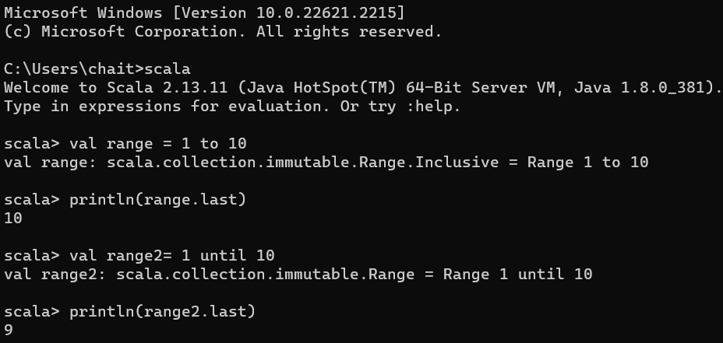

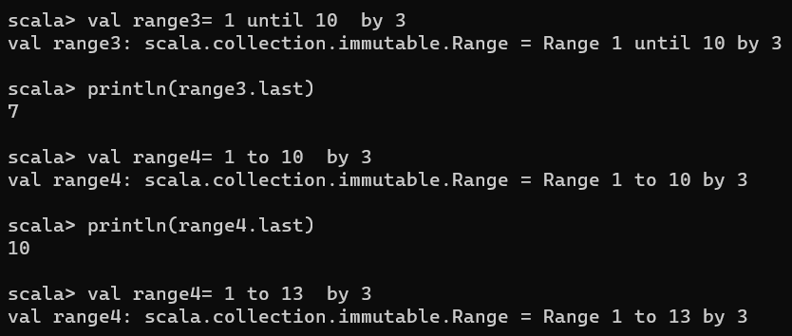

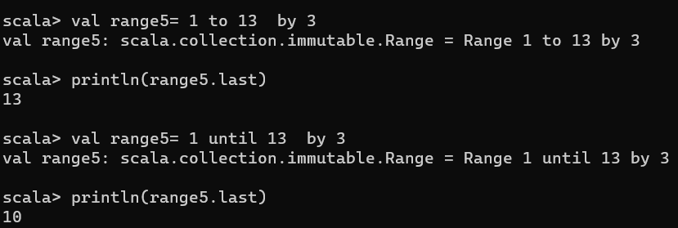

TUPLES:

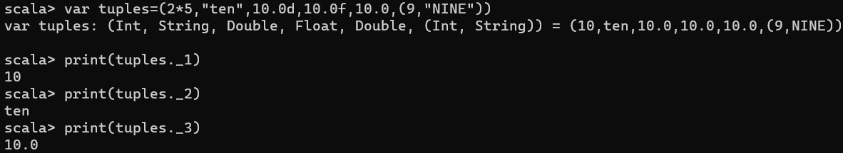

LIST:



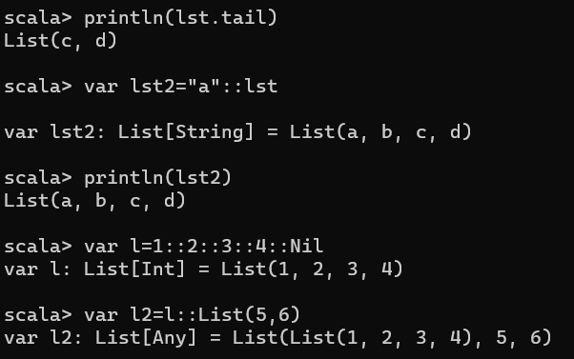

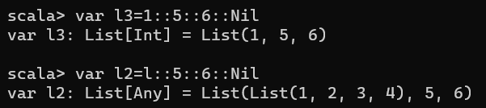

ARRAYS:

